PoE Extend Switch
PW2020-5G-IN

Product Features

- Using CAT.5 network patch cords support power for the wireless AP/CPE and IP camera/PTZ
- Networking standard: IEEE802.3af/at/bt.
- POE power light blinks to determine the power status of the receiving end, and each blink is 2.7 watts.
- PoE Watchdog AI Function: Detection front-end PoE cameras and PD, Automatic detection, Automatic restart
- Support 60W PoE receiving power, free of power adapter & simplify power supply
- 6KV lightning protection,8KV surge protection, anti-reverse connection, over-current protection, over-voltage protection, over-temperature protection, Short circuit protection
- The Max output power of the port is 60W, which is convenient for hi-power equipment
- Zero configuration feature power supply is automatically supplied to the adaptive equipment

Ordering Information

Model | Comment
PW2020-5G-IN | PoE Extend Switch

Model | PW2020-5G-IN
Ports | 4X10/100/1000Mbps PoE ports (RJ45)  1X10/1000Mbps uplink port (RJ45)  1X10/1000Mbps SFP
Transmission Rate | 2000Mbps Full Duplex; 10 or 100 or 1000Mbps Half Duplex
Transmission Distance | 0-100m
Performance  Specification | Bandwidth: 12.0Gbps
 | Network Latency (10 to 1000Mbps): ≦16μs (use the 64byte package size)
 | MAC address table: 8K
 | The Frame Filter & Transmission Rate: 14800pps the most for 10M port, 148800pps the most for 100M port,1488000pps the most for 1000M port
Networking  Standard | IEEE 802.3i 10BASE-T
 | IEEE 802.3u 100BASE-TX/ IEEE 802.3ab 1000BASE-T
 | IEEE 802.3xFlowControl
 | IEEE 802.3af/at/bt Power over Ethernet
Power Support | Power input: DC 12~52V; PoE powered by Total≤60W  PoE Watchdog: Port 1~4  Power output: PoE1~3Port:1/2(+52V),3/6(GND)≤30W  PoE 4 Port:1245(+53V),3678(GND) compatible1/2(+52V),3/6(GND)≤60W
Protection Level | Lightning Protection: 6KV, Per: IEC61000-4-5  ESD Protection: 8KV, Per: IEC61000-4-2
Physical Specifications | Size(L*W*H)：130mm*65mm*31mm
Working  Environment | Operating Temperature: -10℃ ~ 55℃ ( -14° ~ 131℉)
 | Storage Temperature: -40℃ ~ 70℃ ( -104° ~ 158℉)
 | Operating Humidity: 10% ~ 90% non-condensing
 | Storage Humidity: 5% ~ 90% non-condensing
Electromagnetic Compatibility | FCCPart15，Class B
 | CE mark
 | VCCI Class BEN55022 (CISPR 22)
 | C-Tick
Warranty | Whole machine: 1 year
Package Content | Installation Manual
Product Specifications

WATCHDOG

Auto- Detect and restart IP Camera Timely if the camera is halted.

6KV Lightening 8KV ESD

Reaching 6KV lightning and 8KV Static electricity protection, the PoE ports owns the capacity to keep the PoE Switch from lightning strikes and other electrical surges, offering reliable performance even in some harsh environments
Powered By PoE (PD Feature)

The LAN1 port is powered by PoE and provides power for four downlink ports (60W); free of power adapter & simplify power supply; play a role of Ethernet extender
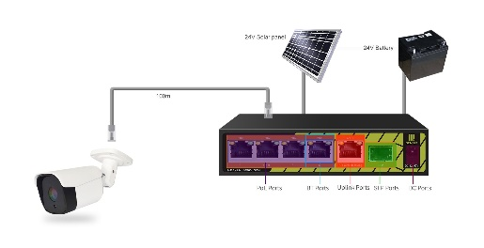
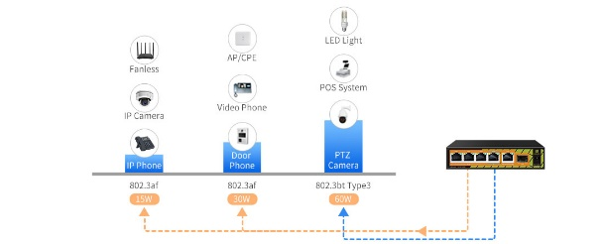
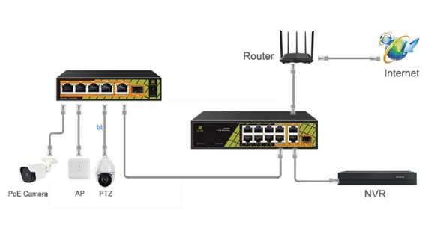
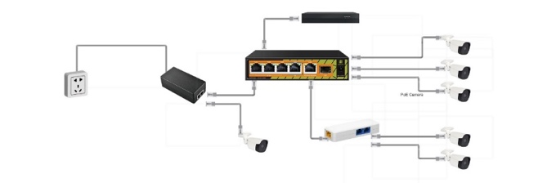
Typical Application

Port Description

Supply 60W High Power

60W high-power port to meet the needs of more and more high-power powered devices

Petawise Inc.

Unit 8-9, 1040 Martin Grove Road, Etobicoke, Ontario, Canada M9W 4W1
Sales@petawise.com; Marketing@petawise.com
www.petawise.com

*Product specifications and availability are subject to change without notice.

